**PS_Lab08**

**01)**

**02)**

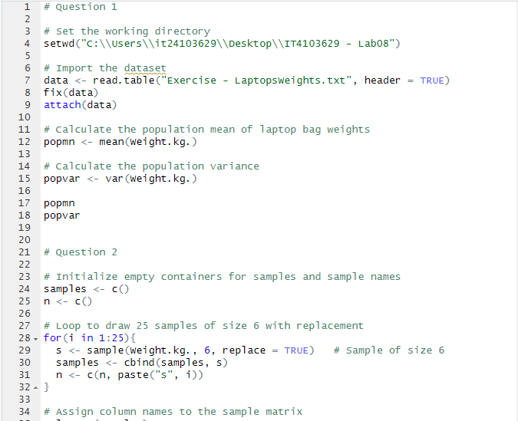

**03**)